**PROGRAM – 1**

class Player{

String name;

int age;

Player(String n,int a){

name=n;

age=a;

}

void show()

{

System.out.println("Player name: "+name);

System.out.println("Age: "+age);

}

}

class cricket_player extends Player{

String type;

cricket_player(String n,String t,int a){

super(n,a);

type=t;

}

public void show()

{

super.show();

System.out.println("Player type : "+type);

}

}

class football_player extends Player{

String type;

football_player(String n,String t,int a)

{

super(n,a);

type=t;

}

public void show()

{

super.show();

System.out.println("Player type : "+type);

}

}

class hockey_player extends Player{

String type;

hockey_player(String n,String t,int a)

{

super(n,a);

type=t;

}

public void show()

{

super.show();

System.out.println("Player type : "+type);

}

}

public class Main{

public static void main(String args[])

{

cricket_player c=new cricket_player("Rohit","Cricket",20);

football_player f=new football_player("Rahul","Football",21);

hockey_player h=new hockey_player("Aditya","Hockey",22);

c.show();

f.show();

h.show();

}

}

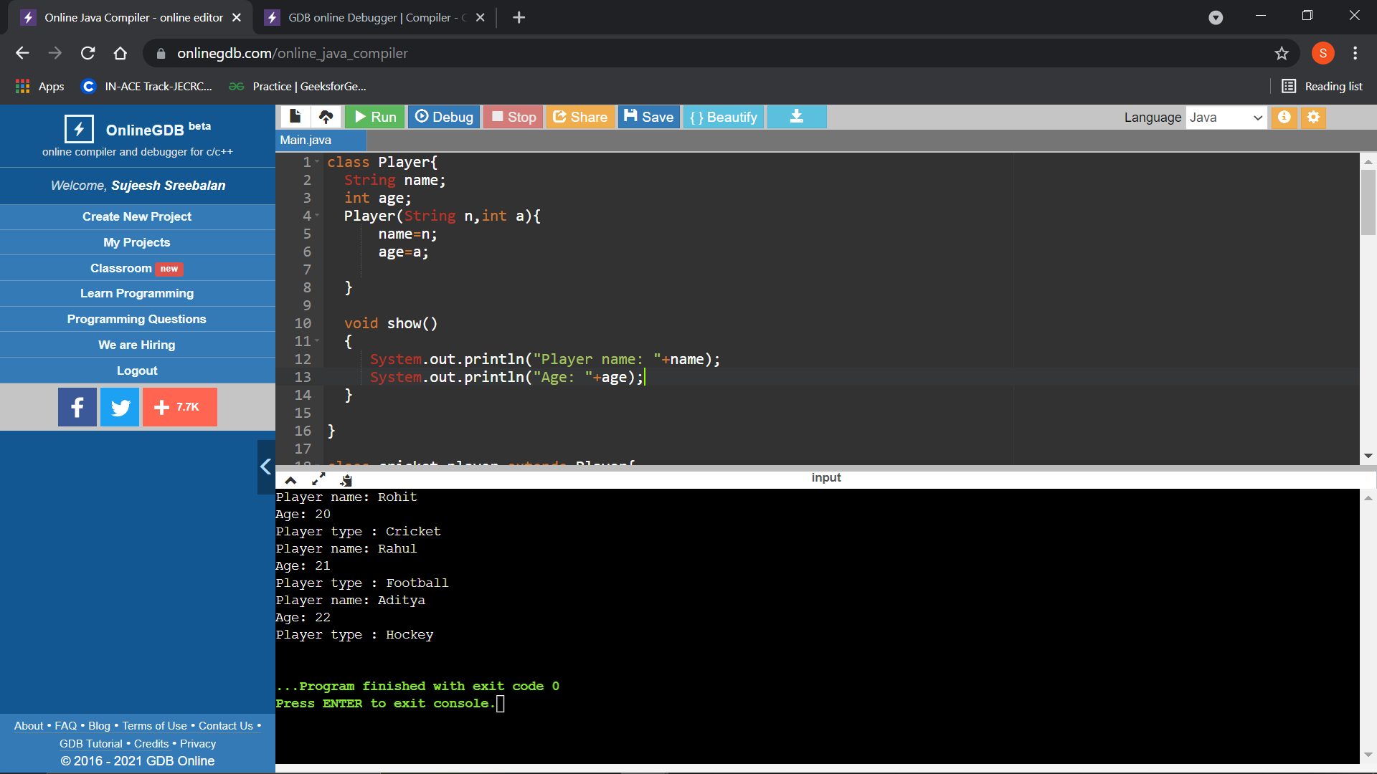

**PROGRAM - 2**

class Rectangle{

int length, breadth;

Rectangle(int l, int b){

length = l;

breadth = b;

}

void area(){

System.out.println("Area of Rectangle: "+(length*breadth));

}

void perimeter(){

System.out.println("Perimeter of Rectangle: "+ (2*(length+breadth)));

}

}

class Square extends Rectangle{

int side;

Square(int s, int l, int b){

super(l, b);

side = s;

}

public void area(){

super.area();

System.out.println("Area of Square: "+(side*side));

}

public void perimeter(){

super.perimeter();

System.out.println("Perimeter of Square: "+(4*side));

}

}

public class Main

{

public static void main(String[] args) {

Square sq = new Square(8, 20, 15);

sq.area();

sq.perimeter();

}

}

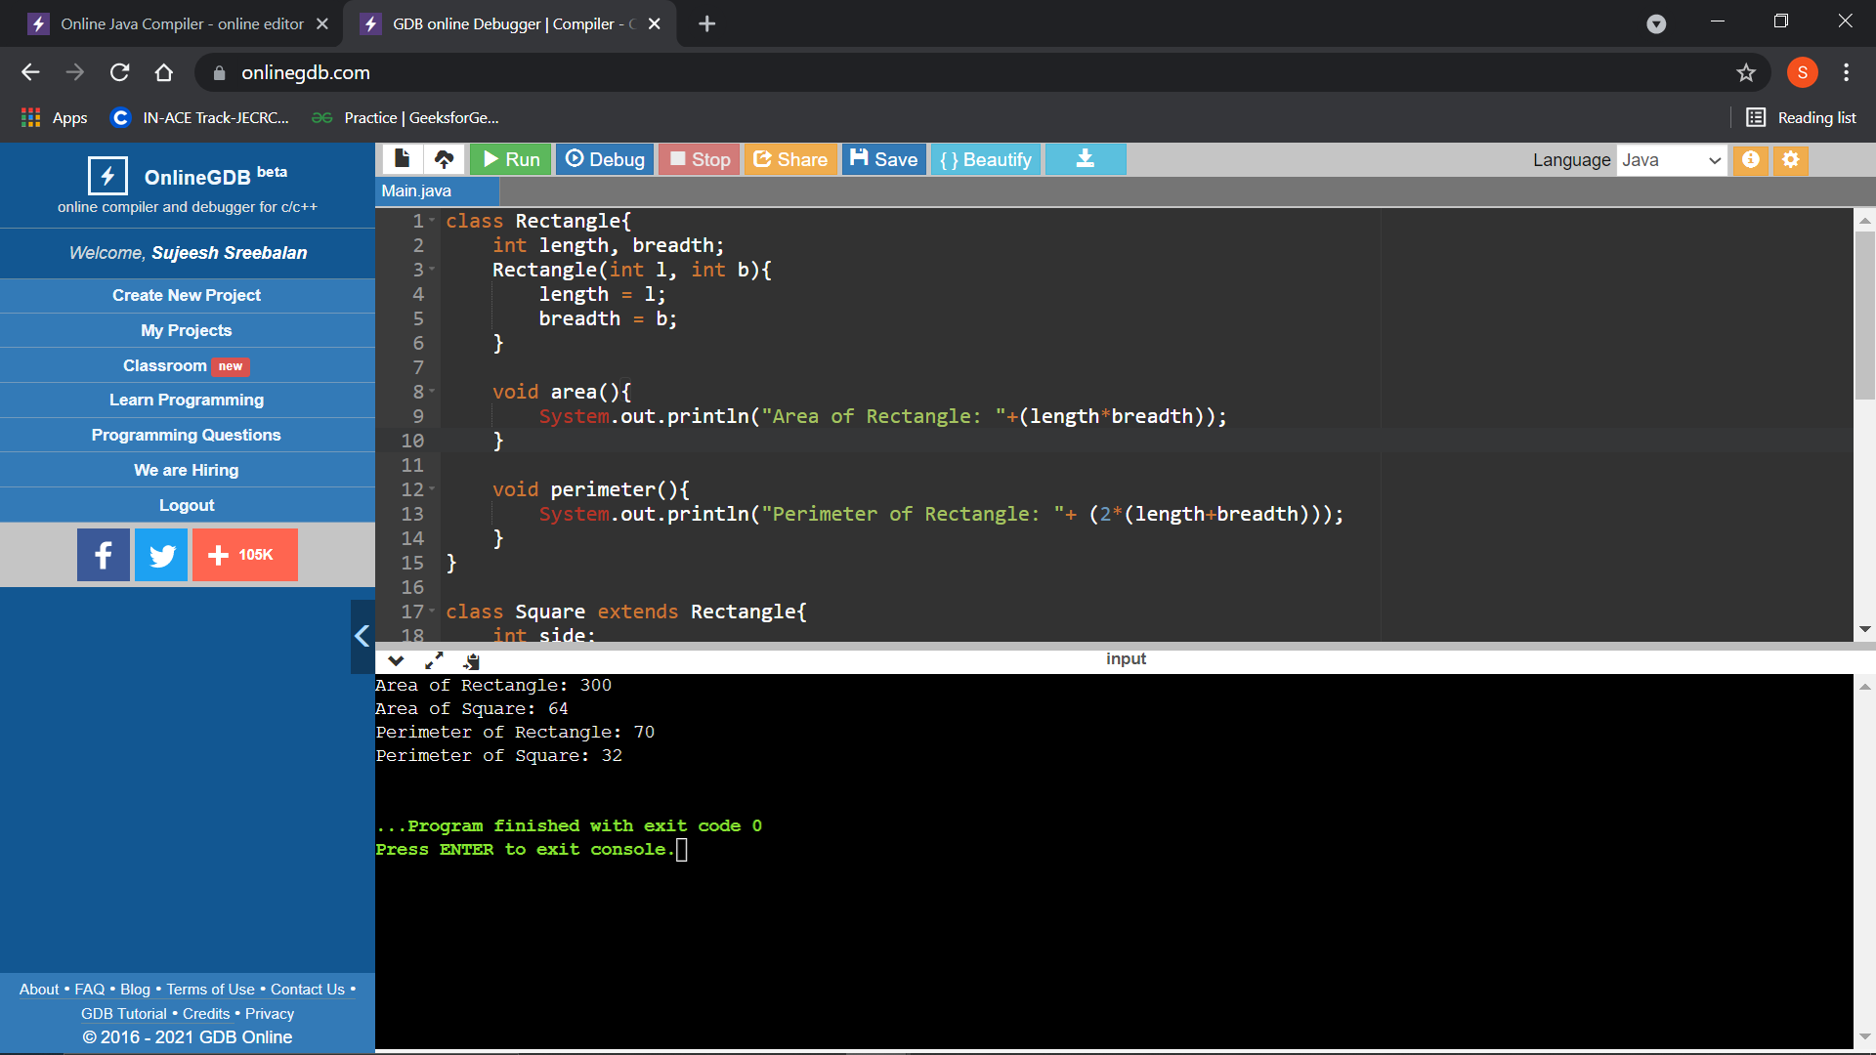

**PROGRAM – 3**

interface Printable // creating Interface 1

{

void print();

}

interface Showable // creating Interface 2{

void show();

}

class Demo implements Printable,Showable{

public void print()

{

System.out.println("Welcome");

}

public void show()

{

System.out.println("Interface Demo");

}

}

public class Main{

public static void main(String args[])

{

Demo obj = new Demo();

obj.print();

obj.show();

}

}

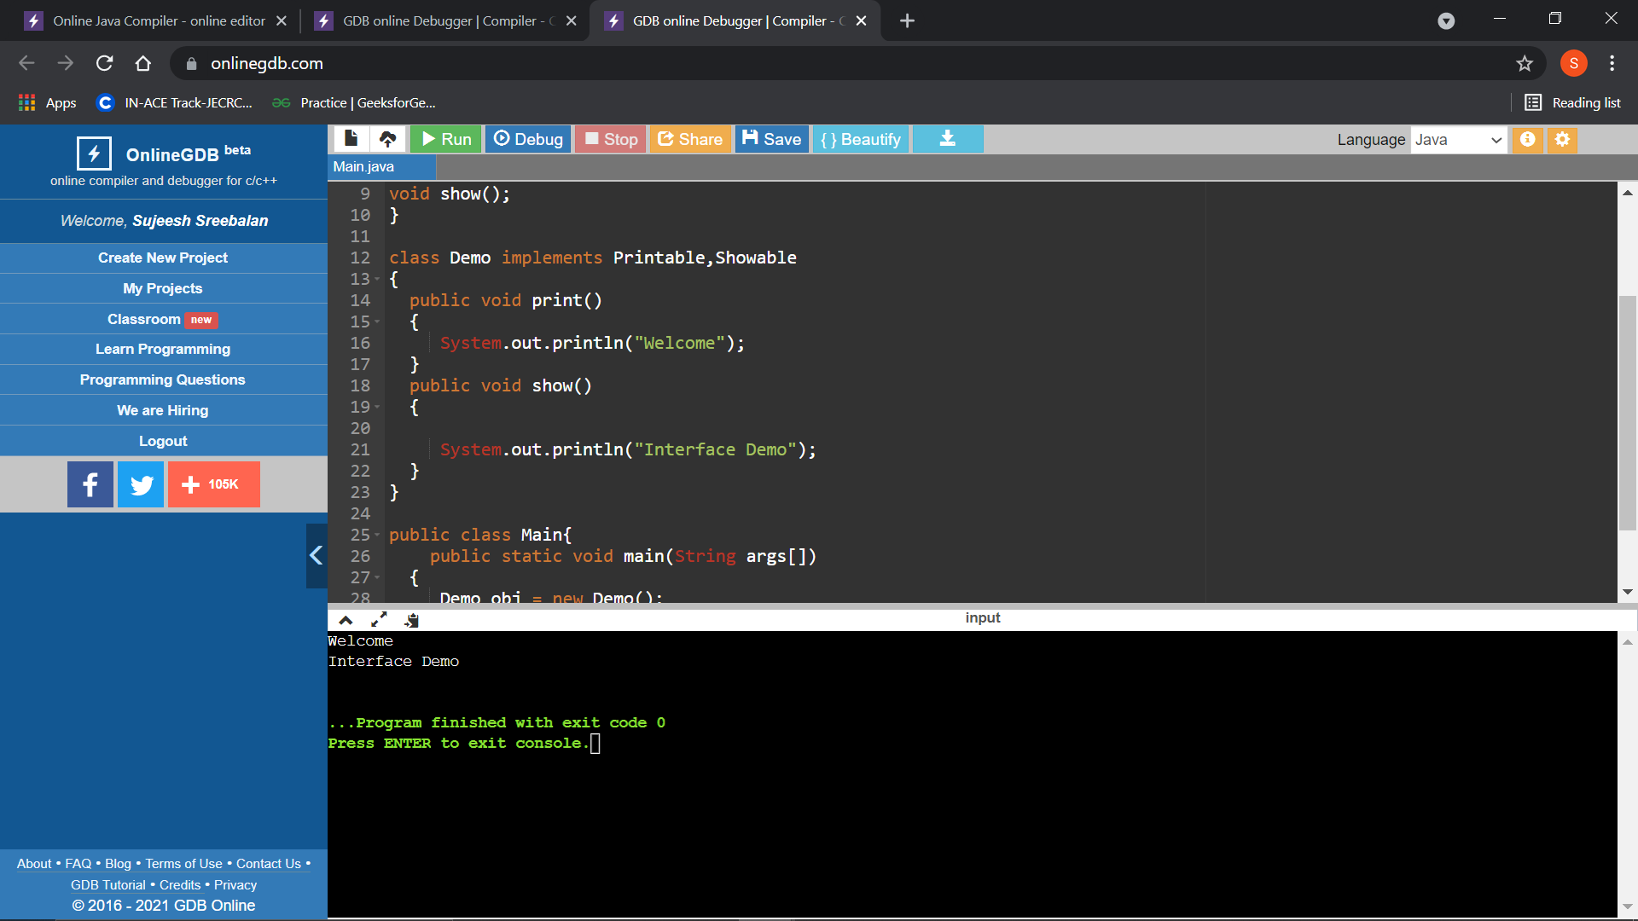

**PROGRAM – 4**

interface Animal // creating Interface 1

{

int a=10; // implicitly static and final

void eat(); //methods of interface are implicitly public

void sleep();

}

class Demo implements Animal

{

public void eat()

{

System.out.println("Animal Eats!");

}

public void sleep()

{

System.out.println("Animal Sleeps!");

System.out.println("Static variable: "+a);

}

}

public class Main{

public static void main(String args[])

{

Demo obj = new Demo();

obj.eat();

obj.sleep();

}

}

